How to collect a water sample to get the best results from a Nitrate screening.

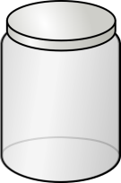
- Collect about a cup of water in a clean container - a glass jar is preferred but other containers will work fine too

- The water sample should be collected before any treatment devices such as water softeners, disinfection units, or faucet filters.

- Run the water for 3 to 5 minutes before collecting the sample to flush out all the water in the plumbing. This ensures the water sample collected is representative of water in the well.

The nitrate screening is intended for testing water from private wells that provide domestic water to your household. Note that our screening is less accurate than a lab test, but it will give you a good idea of your nitrate level. For most households, this result is all you need.

If you receive your drinking water from a public water system and want to know the nitrate levels in your water, the name of your water provider can be found on your most recent water bill. Public water systems are required to sample and test for contamination on a regular basis and report the results to the consumers. You can get the most recent "Consumer Confidence Report" for your water system from the water provider.

