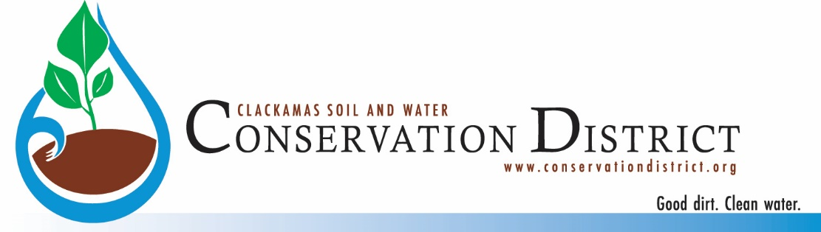

Conservation Investments Coordinator
Announcement – July 2022

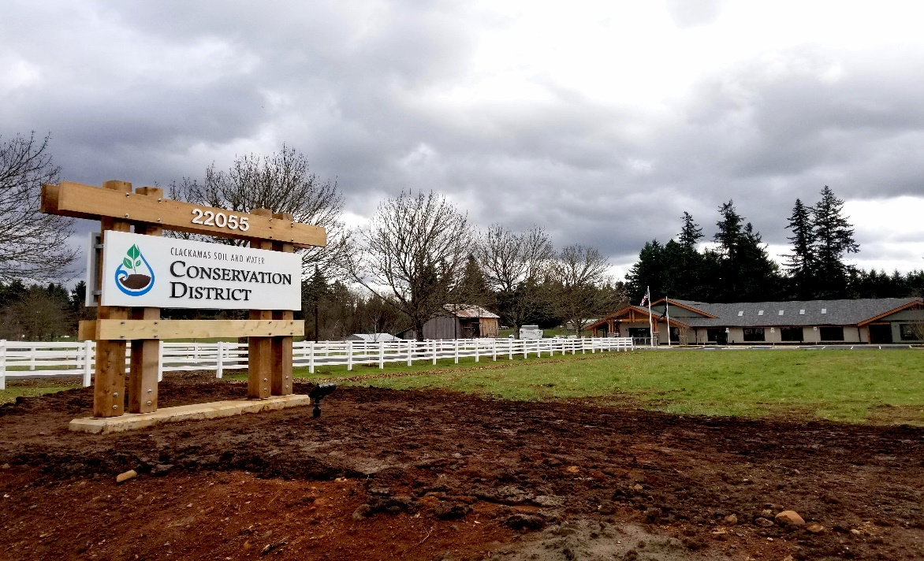

Clackamas Soil and Water Conservation District (District) is hiring an administer of the District’s Grants and Conservation Loans Program. This position supports the District’s conservation mission through the development and management of grants and loans that provide assistance to partner organizations and county residents. We are looking for individuals who want to apply their passion for conservation in Clackamas County. Our goal is to create a high-quality job experience for a conservation-minded professional.

Successful applicants will:
- Demonstrate a broad range of professional, technical, and administrative capabilities to develop, implement, and coordinate innovative multi-faceted funding programs and projects to support and enhance core District rural and urban program priorities and objectives.
- Be responsible in working closely with the District manager and Fiscal Administrator to implement an effective loan and grant program. The Conservation Investments Coordinator will work with staff to formulate and refine policies and procedures, ensure compliance with the terms of grant agreements, maintain fiscal responsibility, and provide exceptional customer service to the public and grantees.
- Provide technical assistance to District staff as needed for adequacy and compliance with applicable rules, regulations, and policies associated with grants and loans.
- Possess strong desire to work in the field of natural resources.
- Be committed to diversity, equity, and inclusion, and an ability to embrace differing perspectives from their own are important for this position.
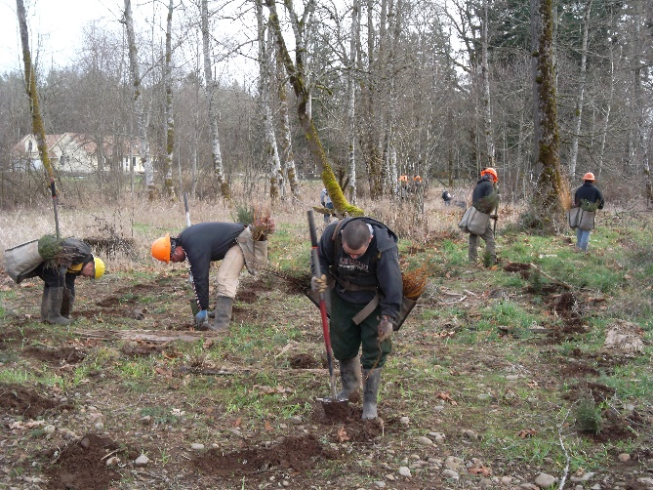
- Identify new funding opportunities to broaden the conservation mission of the District.
- Communicate clearly and effectively.
- Be willing to collaborate with a team
- Provide superior customer service to the public, landowners, partners, and CSWCD staff.

If you have 3 or more years in grant oversight and administration experience in a professional environment OR a bachelor’s degree in a field related to program management, grants management, or contracts management, please consider applying for this position.

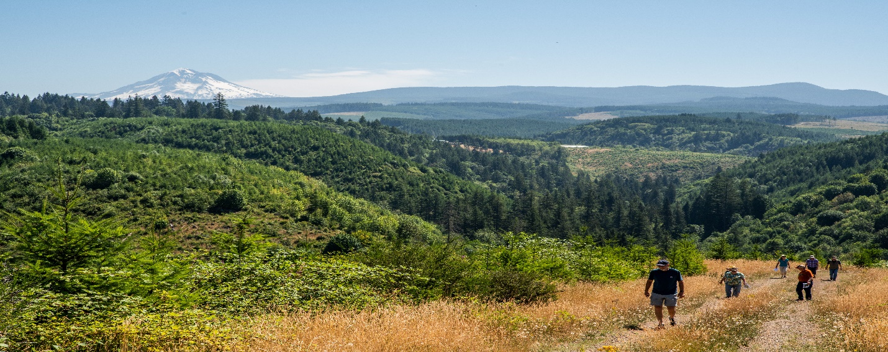
Clackamas Soil and Water Conservation District is a regional leader in conserving natural resources in Oregon and offers a competitive wage schedule and an excellent benefits package. The office is in the Hamlet of Beavercreek, Oregon which is just 5 miles south of Oregon City, the county seat of Clackamas County, an area rich in history as the end of the Oregon Trail and the state’s original capital. Located near the southern limits of the metropolitan Portland, the area supports a wide diversity of high-quality outdoor recreation opportunities; top rated dining and shopping; as well as the hub of world class micro brews and wineries.

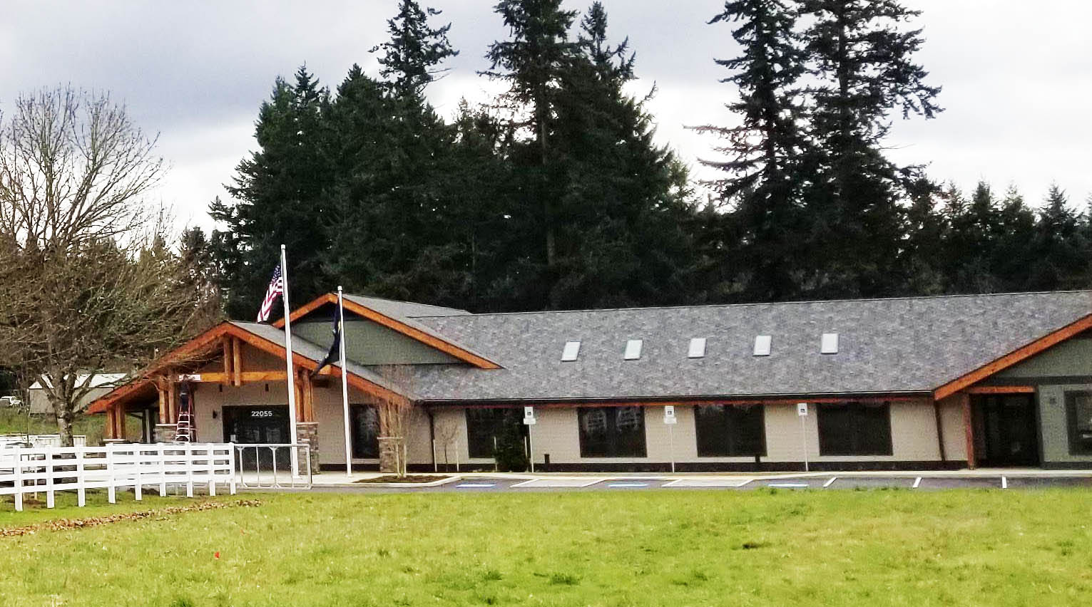
The District recently completed the construction of a state-of-the-art Conservation Resource Center. The 10,851 square foot facility supports the District, NRCS, and FSA staff and on a beautiful 15-acre farm.

A full position description and an application form are available at https://conservationdistrict.org . To apply please send a completed application, resume, and cover letter to 22055 S. Beavercreek Road, Suite 1, Beavercreek, OR 97004, or provide it electronically to District Manager Christopher Lapp at clapp@conservationdistrict.org All application materials must be received by August 31, 2022 by 4:30 p.m.

