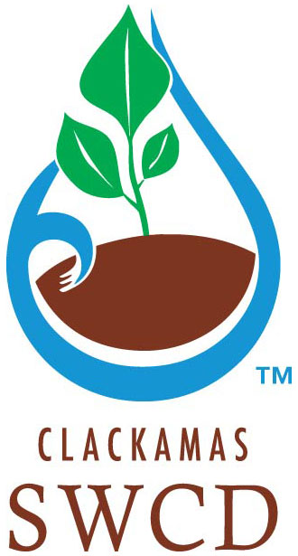

#2022-LMP-01

FOREST FUELS REDUCTION SERVICES

Proposal Forms
  - To be returned to Clackamas Soil and Water Conservation District

PROPOSAL FORM #1

Company Information:
Company Name
Owner/Manager |  |  |  |  | Number of Employees
Email Address
Phone Number |  |  |  |  |  | Fax Number
Mailing Address
Business License # and type | Exp. Date | Oregon Department of Agriculture Herbicide License # and type |  |  | Exp. Date
Oregon DBE/MBE/WBE/ESB/SDVBE Certification & Type: |  |  |  | CCB #

Cooperative Procurement:
Check the appropriate box.
☐ Yes: Other Agencies may purchase at the unit prices and/or hourly labor rates contained in the proposal.
☐ No: Other Agencies may not purchase at the unit prices and/or hourly labor rates contained in the proposal.

  - This proposal will be valid for ninety (90) days.

  - By completing and signing this proposal, the proposer acknowledges that:
No officer, agent, or employee of the District has a pecuniary interest in this proposal or has participated in contract negotiations on behalf of the District; the proposal is made in good faith without fraud, collusion, or connection of any kind with any other Proposer for the same call for proposals; and the Proposer is competing solely in its own behalf without connection with, or obligation to, any undisclosed person or firm.

Submitted on behalf of:

Name of Contractor

Name of Authorized Representative

Title of Authorized Representative:

Signature of Authorized Representative:

Name Date of Signature:

PROPOSAL FORM #2

References:
Provide a minimum of two (2) references for vegetation management work that you have completed.
Company Name/Project | Type of Work | Term of Contract/Amount | Contact Person | Phone Number

Provide the following requested information on separate paper without exceeding eight (8) total pages

Company Capacity:
Describe your company’s capacity to conduct fuels reduction as described in the scope of work on 23 acres of forest.

Experience:
Describe company experience with fuels reduction projects and practices described in the scope of work.

Sustainable Business Practices:
Describe steps your company has taken to utilize sustainable business practices on a regular basis. Examples include use of recycled paper, use of biodiesel, recycling of materials, etc.

Diversity in Employment and Contracting:
Describe efforts your company has made on past or current projects to ensure a diverse workforce, including policies and practices to promote the hiring of women and ethnic minorities. List if your business, businesses that you intend to sub-contract with, or businesses that you purchase materials from have Disadvantaged, Minority-Owned, Women-Owned, Emerging Small Businesses, Service-Disabled Veterans Business Enterprises (DBE/MBE/WBE/ESB/SDVBE) statuses with the State of Oregon.

