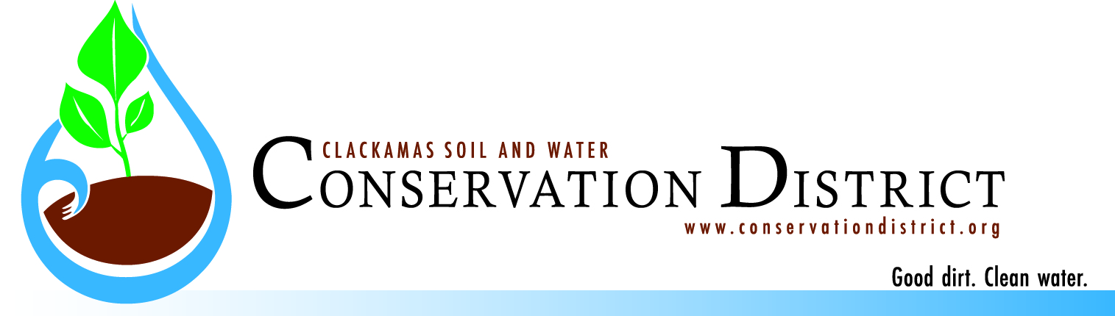
Clackamas Soil and Water Conservation District
Scholarship Application Form
- Name: ________________________________________________________________________
First Middle Last
- Permanent Mailing Address:
______________________________________________________________________________
Street/PO Box # City State Zip
- Telephone and E-mail Address:
______________________________________________________________________________
Phone E-mail
- Applicant is currently enrolled in what institution of higher education?
______________________________________________________________________________
- What institute of higher education will the applicant be attending in fall 2022?
______________________________________________________________________________
- In fall 2022, the applicant will be: Sophomore ___ Junior ___ Senior ___ Grad Student ___
- Major Course of Study _______________________________________________________
- Please list high schools, junior colleges, and colleges you have attended. Include dates of attendance and graduation.
Schools Dates
_____________________________________ __________________________
_____________________________________ __________________________
_____________________________________ __________________________
______________________________________ __________________________

- List participation in scholastic organizations, school activities or civic activities (if additional room is needed, attach a page):
_____________________________________________________________________________________
_____________________________________________________________________________________
- List recognitions, awards and honors received for civic or scholastic activities (if additional room is needed, attach a page):

_____________________________________________________________________________
_____________________________________________________________________________________
- Describe your top three leadership experiences (if additional room is needed, attach a page):

______________________________________________________________________________
_____________________________________________________________________________________
____________________________________________________________________________________
- List any work or practical experience you have in the agricultural or natural resources field (if additional room needed, attach a page):
_____________________________________________________________________________________
_____________________________________________________________________________________
_____________________________________________________________________________________
- Submit, in one page or less, your career goals in agriculture or natural resources and how your goals would benefit what we do at the Clackamas Soil and Water Conservation District.

- How did you hear about this scholarship?______________________________________

- Applicant certifies that the information provided in this application form is true.
Applicant agrees that if selected for a scholarship, applicant will attend the institution listed above and will pursue the major course of study listed in the application for the duration of the academic year.
Applicant understands and agrees that failure to comply with the above may render applicant ineligible for the scholarship granted and applicant may be required to return any remaining unused portions of the scholarship award to the CSWCD.
It is understood that submission of this completed application gives permission to the Clackamas Soil and Water Conservation District to utilize your name and/or picture for promotional purposes to further the mission of the Clackamas Soil and Water Conservation District.

Dated this__________________day of ___________________, 2022.

Applicant Signature

__________________________________________________________________________

