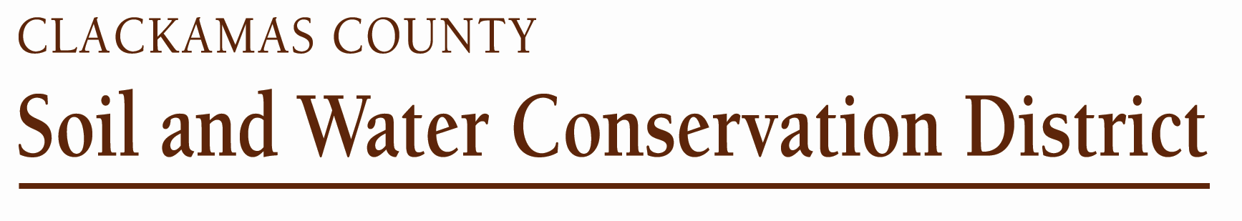

Cooperator Agreement
Between
Clackamas County Soil and Water Conservation District
And

Cooperator Name: ________________________Name of Operation:_______________

I am interested in conserving the natural resources on my property. I would like to receive assistance in developing a complete soil and water conservation plan for my land.

Once a conservation plan is developed, I agree to follow the recommendations of the District to the best of my ability.

We, the Clackamas County Soil and Water Conservation District, agree to help you develop a conservation plan for your property.

_____________________________________ ________________
Property Owner Date

_____________________________________ ________________ District Manager Date

Authorization for Release of Conservation Plan File Information

Persons receiving contracted services or financial assistance through the Clackamas County Soil and Water Conservation District (CCSWCD) to implement conservation projects are required to comply with all Federal, State, and local laws and to obtain any required Federal, State or local permits prior to construction of a project. In order to ensure compliance, CCSWCD may be required to release a minimum amount of information as it pertains to the property and/or project to Federal, State and local partnering agencies.

Authorization: I authorize the CCSWCD to release information pertaining to the conservation plan and its implementation to Federal, State and/or local agencies and funding sources.

Signature: ___________________________________________ Date: ________________

